**Sporty Shoes**

1.user registration

2.login

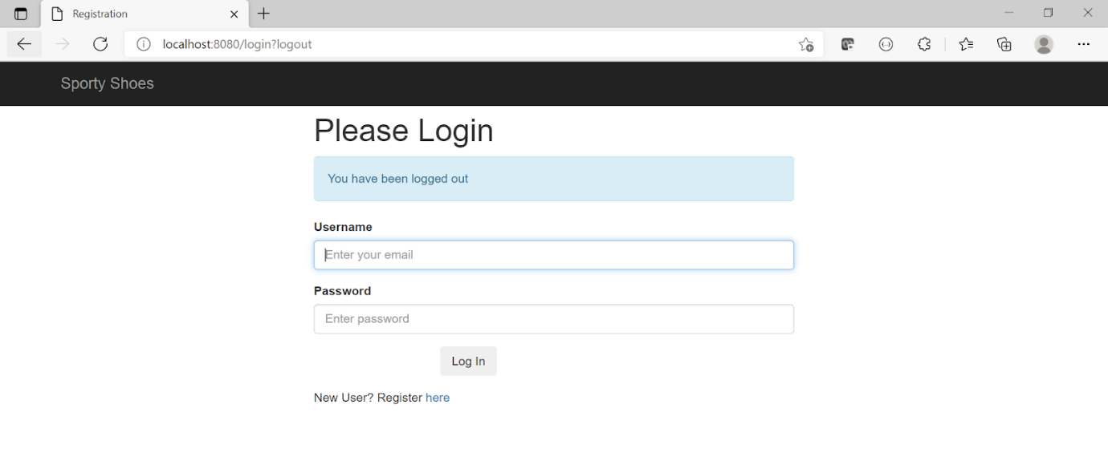

3.Giving Adress

4.Purchase list

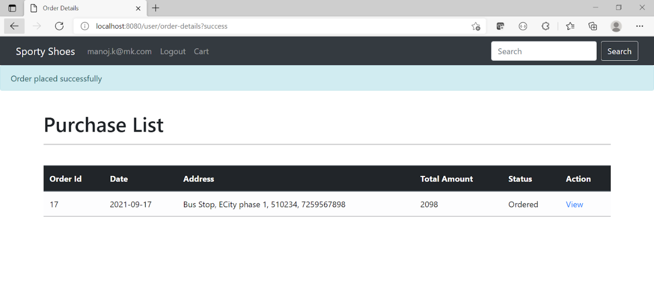

5.login



6.Admin page

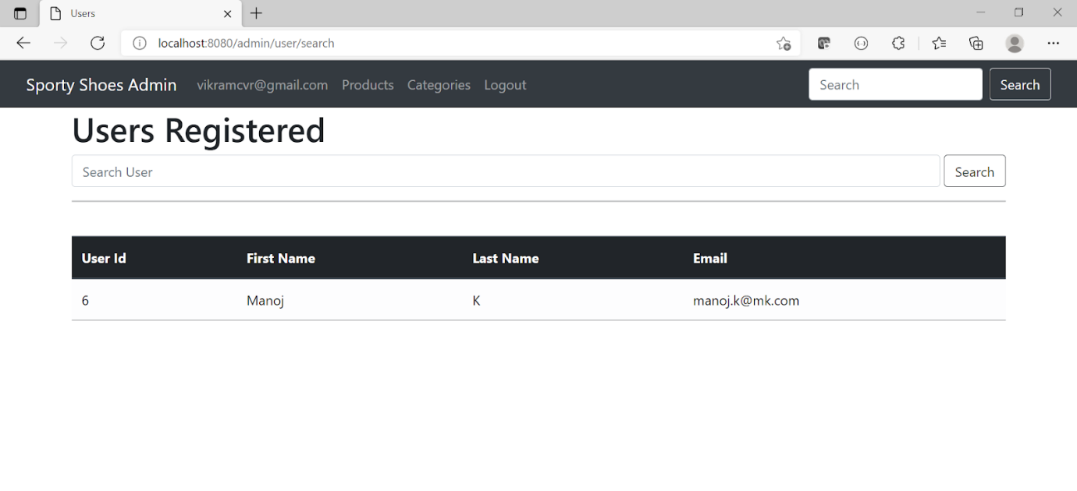

7.change password

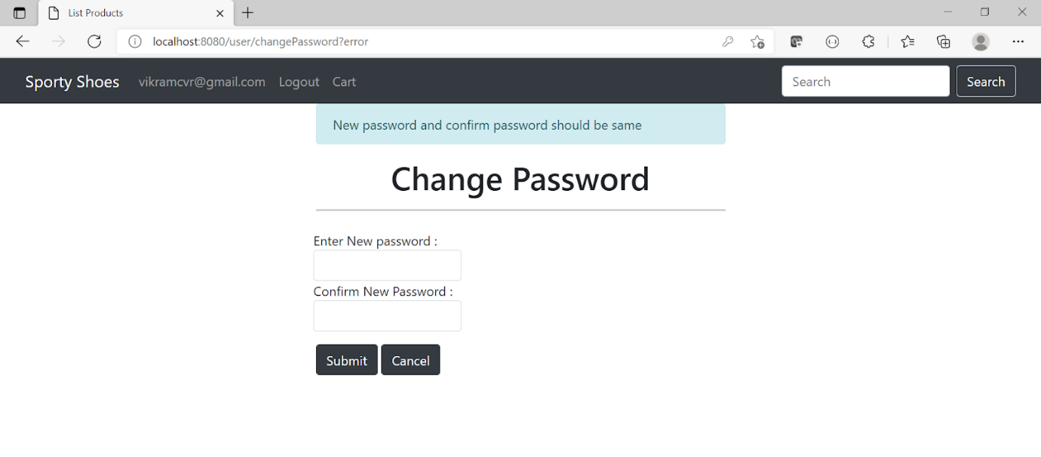

8.add new category

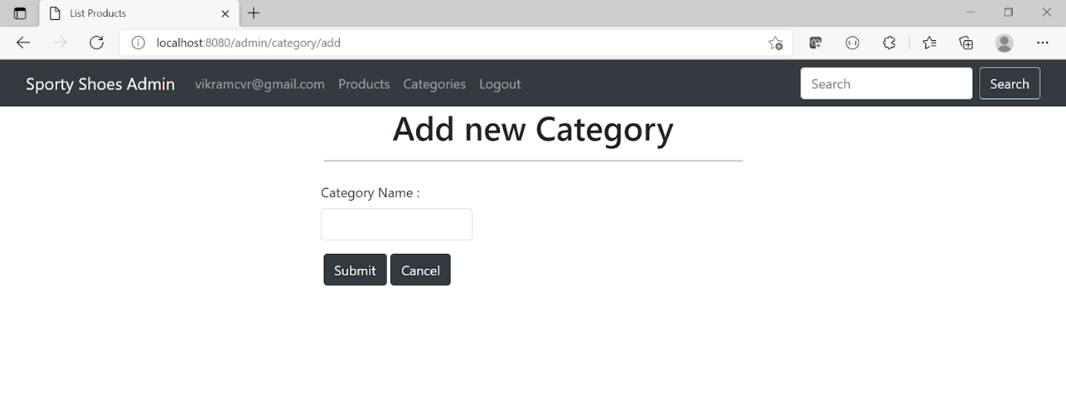

9.All catogeries

